ECE 442 Final Project Demo

Sumant Sakhalkar (CSU ID: 831685037)

Q1)

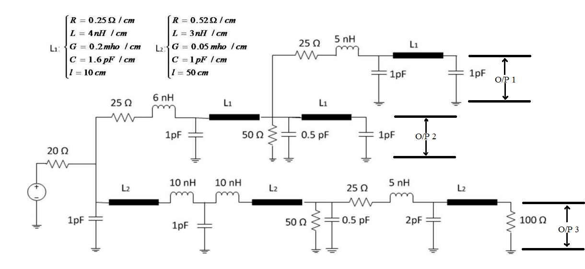

Frequency Domain Analysis

Bandwidth of interest: 100 KHz – 10 GHz

# Frequency points: 600

For TL1, n = 160

For TL2, n = 548

We are increasing the number of lumped section by a value of ‘z’ until we get to a point where the current output is almost equal to the previous value of ‘z’ ie. point of saturation.

For z = 50







For z=80







For z = 110







For z = 150







|  |  |  |  |  |  |  |  |  |
| --- | --- | --- | --- | --- | --- | --- | --- | --- |
|  |  |  |  |  |  |  |  |  |
|  |  |  | **Section(n)** | **CPU Time(s)** |  |  |  |  |
|  |  |  | 160 | 2563 |  |  |  |  |
|  |  |  | 210 | 4.55E+03 |  |  |  |  |
|  |  |  | 240 | 7.39E+03 |  |  |  |  |
|  |  |  | 270 | 8.76E+03 |  |  |  |  |
|  |  |  | 310 | 1.00E+04 |  |  |  |  |
|  |  |  |  |  |  |  |  |  |
| |  | | --- | |  | |  |  |  |  |  |  |  |  |
|  |  |  |  |  |  |  |  |  |
|  |  |  |  |  |  |  |  |  |
|  |  |  |  |  |  |  |  |  |
|  |  |  |  |  |  |  |  |  |
|  |  |  |  |  |  |  |  |  |
|  |  |  |  |  |  |  |  |  |
|  |  |  |  |  |  |  |  |  |
|  |  |  |  |  |  |  |  |  |
|  |  |  |  |  |  |  |  |  |
|  |  |  |  |  |  |  |  |  |
|  |  |  |  |  |  |  |  |  |
|  |  |  |  |  |  |  |  |  |
|  |  |  |  |  |  |  |  |  |
|  |  |  |  |  |  |  |  |  |
|  |  |  |  |  |  |  |  |  |

Time Domain Analysis

Time range of simulation: 0 - 10 ns

# Time points: 1000 points with fixed time step = 10psec

For TL1, n = 160

For TL2, n = 548

We are increasing the number of lumped section by a value of ‘z’ until we get to a point where the current output is almost equal to the previous value of ‘z’ ie. point of saturation.

For Backward Euler

For z = 0



For z = 50



For z= 80



For z = 110



For z = 150



|  |  |  |  |  |  |  |  |  |
| --- | --- | --- | --- | --- | --- | --- | --- | --- |
|  |  |  |  |  |  |  |  |  |
|  | Q1 CPUTime Analysis For Backward Euler | | | | | |  |  |
|  |  |  |  |  |  |  |  |  |
|  |  |  | **Section (n+z)** | **CPU Time(s)** |  |  |  |  |
|  |  |  | 160 | 240.1952 |  |  |  |  |
|  |  |  | 210 | 315.6432 |  |  |  |  |
|  |  |  | 240 | 2.77E+02 |  |  |  |  |
|  |  |  | 270 | 3.16E+02 |  |  |  |  |
|  |  |  | 310 | 5.67E+02 |  |  |  |  |
|  |  |  |  |  |  |  |  |  |
|  |  |  |  |  |  |  |  |  |
| |  | | --- | |  | |  |  |  |  |  |  |  |  |
|  |  |  |  |  |  |  |  |  |
|  |  |  |  |  |  |  |  |  |
|  |  |  |  |  |  |  |  |  |
|  |  |  |  |  |  |  |  |  |
|  |  |  |  |  |  |  |  |  |
|  |  |  |  |  |  |  |  |  |
|  |  |  |  |  |  |  |  |  |
|  |  |  |  |  |  |  |  |  |
|  |  |  |  |  |  |  |  |  |
|  |  |  |  |  |  |  |  |  |
|  |  |  |  |  |  |  |  |  |
|  |  |  |  |  |  |  |  |  |
|  |  |  |  |  |  |  |  |  |
|  |  |  |  |  |  |  |  |  |
|  |  |  |  |  |  |  |  |  |

For Trapezoidal

For z = 0



For z = 50



For z = 80



For z = 110



For z = 150



|  |  |  |  |  |  |  |  |  |
| --- | --- | --- | --- | --- | --- | --- | --- | --- |
|  |  |  |  |  |  |  |  |  |
|  | Q1 CPU Time Analysis For Trapezoidal | | | | | |  |  |
|  |  |  |  |  |  |  |  |  |
|  |  |  | **Section (n+z)** | **CPU Time(s)** |  |  |  |  |
|  |  |  | 160 | 190.6542 |  |  |  |  |
|  |  |  | 210 | 193.0302 |  |  |  |  |
|  |  |  | 240 | 2.26E+02 |  |  |  |  |
|  |  |  | 270 | 2.56E+02 |  |  |  |  |
|  |  |  | 310 | 2.88E+02 |  |  |  |  |
|  |  |  |  |  |  |  |  |  |
|  |  |  |  |  |  |  |  |  |
| |  | | --- | |  | |  |  |  |  |  |  |  |  |
|  |  |  |  |  |  |  |  |  |
|  |  |  |  |  |  |  |  |  |
|  |  |  |  |  |  |  |  |  |
|  |  |  |  |  |  |  |  |  |
|  |  |  |  |  |  |  |  |  |
|  |  |  |  |  |  |  |  |  |
|  |  |  |  |  |  |  |  |  |
|  |  |  |  |  |  |  |  |  |
|  |  |  |  |  |  |  |  |  |
|  |  |  |  |  |  |  |  |  |
|  |  |  |  |  |  |  |  |  |
|  |  |  |  |  |  |  |  |  |
|  |  |  |  |  |  |  |  |  |
|  |  |  |  |  |  |  |  |  |
|  |  |  |  |  |  |  |  |  |

Q2)

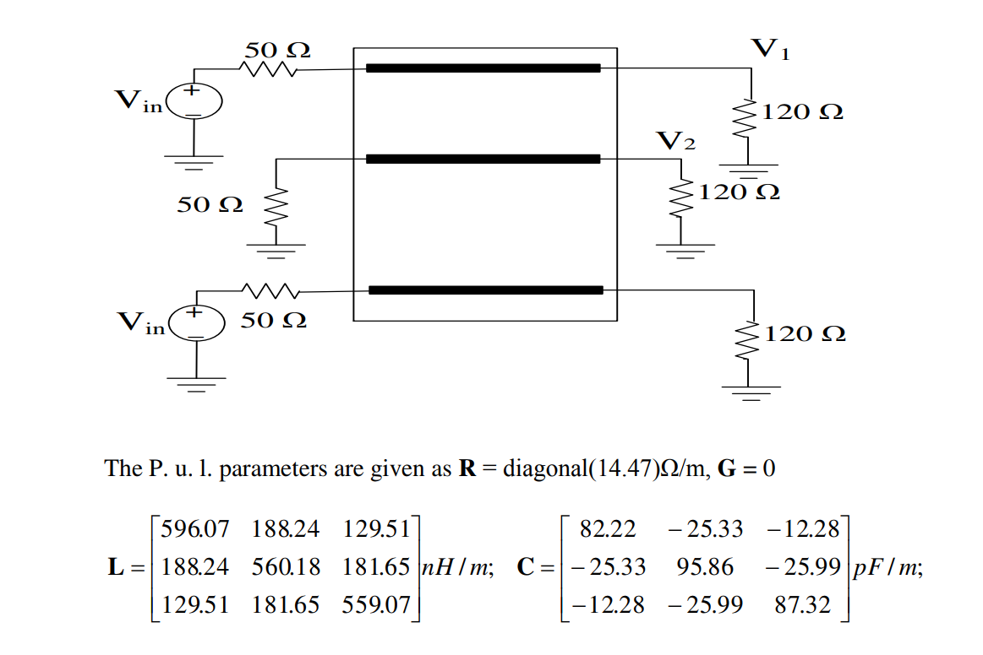

Frequency Domain Analysis

Bandwidth of interest: 100 Khz – 10 Ghz

# Frequency points: 600

We are increasing the number of lumped section by a value of ‘z’ until we get to a point where the current output is almost equal to the previous value of ‘z’ ie. point of saturation.

Although, there are not a lot of changes as we keep on increasing the offset value ‘z’

For z = 0







For z = 5







For z = 20







|  |  |  |  |  |  |  |  |  |
| --- | --- | --- | --- | --- | --- | --- | --- | --- |
|  | Q2 Frequency | | | | | |  |  |
|  |  |  |  |  |  |  |  |  |
|  |  |  | **Section (n+z)** | **CPU Time(s)** |  |  |  |  |
|  |  |  | 0 | 0.779 |  |  |  |  |
|  |  |  | 5 | 1.517 |  |  |  |  |
|  |  |  | 20 | 9.92E+00 |  |  |  |  |
|  |  |  |  |  |  |  |  |  |
|  |  |  |  |  |  |  |  |  |
|  |  |  |  |  |  |  |  |  |
|  |  |  |  |  |  |  |  |  |
| |  | | --- | |  | |  |  |  |  |  |  |  |  |
|  |  |  |  |  |  |  |  |  |
|  |  |  |  |  |  |  |  |  |
|  |  |  |  |  |  |  |  |  |
|  |  |  |  |  |  |  |  |  |
|  |  |  |  |  |  |  |  |  |
|  |  |  |  |  |  |  |  |  |
|  |  |  |  |  |  |  |  |  |
|  |  |  |  |  |  |  |  |  |
|  |  |  |  |  |  |  |  |  |
|  |  |  |  |  |  |  |  |  |
|  |  |  |  |  |  |  |  |  |
|  |  |  |  |  |  |  |  |  |
|  |  |  |  |  |  |  |  |  |
|  |  |  |  |  |  |  |  |  |
|  |  |  |  |  |  |  |  |  |

For the above question the CPU time increases almost exponentially as we increase the lumped sections

Time Domain Analysis

Time range of simulation: 0 - 10 ns

# Time points: 1000 points with fixed time step = 10psec

We increase the distance by 0.5 cm from 0.5cm to 5 cm (Total 10 iterations)

For d = 0.5cm



For d = 1cm



For d = 1.5cm



For d = 2cm



For d = 2.5cm



For d = 3cm



For d = 3.5



For d = 4cm



For d = 4.5cm



For d = 5cm



|  |  |  |  |  |  |  |  |  |
| --- | --- | --- | --- | --- | --- | --- | --- | --- |
|  | Q2 Time | | | | | |  |  |
|  |  |  |  |  |  |  |  |  |
|  |  |  | **Distance (cm)** | **CPU Time(s)** |  |  |  |  |
|  |  |  | 0.5 | 0.5759 |  |  |  |  |
|  |  |  | 1 | 1.3013 |  |  |  |  |
|  |  |  | 1.5 | 3.20E+00 |  |  |  |  |
|  |  |  | 2 | 5.48E+00 |  |  |  |  |
|  |  |  | 2.5 | 8.89E+00 |  |  |  |  |
|  |  |  | 3 | 1.36E+01 |  |  |  |  |
|  |  |  | 3.5 | 1.92E+01 |  |  |  |  |
|  |  |  | 4 | 3.14E+01 |  |  |  |  |
|  |  |  | 4.5 | 4.35E+01 |  |  |  |  |
|  |  |  | 5 | 5.98E+01 |  |  |  |  |
|  |  |  |  |  |  |  |  |  |
|  |  |  |  |  |  |  |  |  |
| |  | | --- | |  | |  |  |  |  |  |  |  |  |
|  |  |  |  |  |  |  |  |  |
|  |  |  |  |  |  |  |  |  |
|  |  |  |  |  |  |  |  |  |
|  |  |  |  |  |  |  |  |  |
|  |  |  |  |  |  |  |  |  |
|  |  |  |  |  |  |  |  |  |
|  |  |  |  |  |  |  |  |  |
|  |  |  |  |  |  |  |  |  |
|  |  |  |  |  |  |  |  |  |
|  |  |  |  |  |  |  |  |  |
|  |  |  |  |  |  |  |  |  |
|  |  |  |  |  |  |  |  |  |
|  |  |  |  |  |  |  |  |  |
|  |  |  |  |  |  |  |  |  |
|  |  |  |  |  |  |  |  |  |